21.95: By symmetry, 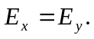 For 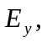compared to problem 21.94, the integral over the angle is halved but the charge density doubles─giving the same result. Thus,
